

**Designed by**

Derek Han

Kendall Reonal

Alex Gingras

Problem Statement

Medical misinformation is a problem. In our initial interviews, we observed that individuals have a tendency to search through the internet for recovery tips, which exposes them to unreliable recovery advice that may cause further harm. According to surgeon Dr. David Hungerford, patients are often coming into his office misinformed. He states that, “Too often patients access information about conditions they have self-diagnosed and bring it to the consultation with their physician, who then has to spend time disabusing the patients of the misinformation they have accumulated.” (Hungerford, D.) After conducting interviews, we observed that recreational athletes who have suffered from medium severity injuries (ie, sprained wrist, twisted ankle, sore elbow, etc) often look for “quick fixes” on the Internet. For example, one of our interviewees, Rohan, conducted internet searches although he already visited the doctor. He stated that the doctor only gave him general guidelines, but he sought alternative recovery methods that would cater to his own specific injury and enable to recover faster. Individuals like Rohan aim to decrease the healing time of their injuries, while sustaining their active lifestyle. Unfortunately, many remedies found on the Internet are myths. In many cases, following these myths for recovery have lead to increase healing time or have caused further aggravation of the injury. The problem is that people believe these myths, not that the myths exist themselves. We aimed to create a tool that would allow users to be worry free when searching for recovery methods on the Internet.

After conducting our semi-structured interviews, we learned that recreational athletes tend to want to get back to being active as soon as possible after suffering a medium-severity injury. In order to do that, our interview subjects used reputable websites, such as WebMD, for recovery information, although they occasionally visited forums like Bodybuilding.com where myths and questionable information exist. For example, Tsuki said that he had to ignore posts in forums due to him not being able to trust the sources. We wanted to design a tool to help users easily filter out recovery advice that might not be trustworthy. In order to do so, we had to narrow down our design and set constraints on what we wanted to produce.

Project Scope

RecoverEase is a Google Chrome extension designed to help people identify and avoid faulty advice on how to recover from sports injuries.  As we mentioned in our problem statement, many people search for “quick fixes” online when they get a sports related injury, but these remedies are often based on false information and can often cause the athlete to take longer to heal or even re-injure themselves.

Now, there are a number of forums and websites which try to address this problem - think reddit.com/sportsmedicine and wikihow.com -  but none of these have had rousing success.  There are a myriad of factors which have led to this, but we have identified and chose to address the two which we think have the largest impact. First of all, these tools are often crowd sourced from ordinary people, which can lead to more false information being spread as well as a sense of false confidence when many non-experts endorse a particular idea.  Secondly, you must navigate to these tools and directly seek out information (which can be easier said than done).  We’ve addressed both these problems by creating a Chrome extension built on doctor curated information which works within many web pages, rather than being housed separately.

At its core, our tool identifies myths within a webpage.  First, it will use natural language processing to identify any recovery methods, as well as the injury they claim to cure.  We will then cross reference these methods with a doctor-curated database of known myths to determine if this particular method is, in fact, a myth.  If it is, we will then flag it for the user and provide a pop up dialog box containing our reasoning (which is, again, doctor-curated).  On top of this core functionality, we will also create an interface where users can track which websites have given them the most false information and choose to block certain websites from their search results, thus allowing them to search smarter and more quickly.

To avoid biting off more than we can chew, we have decided to limit our scope in a number of ways.  First, we will focus only on English language websites discovered by Google using Google Chrome.  This will significantly reduce the complexity of the code and the number of edge cases we run into, thereby dramatically lowering our risk of error.  Secondly, we will only design for people with at least some high school education so we can be relatively sure that they have the skills required to understand the information we are trying to convey.  This is particularly important when it comes to the dialog box explaining why a remedy was flagged because, while we will strive to make this easily understandable, it may still include somewhat complicated scientific concepts such as the reason ice can help certain types of muscle pain, but aggravate others.  Thirdly we will only try to identify recovery myths for medium-severity injuries, which we’ve loosely defined as any injury which causes a significant, but bearable, amount of pain and doesn’t heal within 2-3 days.  This would include, for example, a sprained wrist, jammed thumb, or small fracture, but would not include scrapes and bruises or broken bones.  Finally, we only want to target users who have access to a computer and internet, are physically able to fully use these things, and know how to use Google Chrome, Google Search Engine, and install a Google Chrome Extension (after all, if they don’t know how to do these things, it’s unlikely that they could install our tool in the first place).

**In Summary, our app will focus on:**

* Identification of recovery myths for medium-severity, sports related injuries
* Summarization of various pieces of information about the myths our Google Chrome Extension discovers including what they were and where they were located
* Blocking of websites from Google’s search results at the user’s behest
* English language websites
* Users with at least a high school education
* Users who have access to computers and the internet, and are physically capable of using both fully.
* Users who have a basic knowledge of computers and the internet, including how to install and access a Google Chrome Extension.

**Assumptions and Limitations**

Since our tool has a relatively complicated back end, we have had to make a number of assumptions in our project.

1. We are able to get enough funding and doctor support to curate the database our tool will be built on.
2. Our developers are capable of creating the natural language processing tool required to find the recovery myths on English language websites
3. Our users fit all of the descriptions described in our “Scope” section
4. Our users have already downloaded the extension and know how to access it
5. Our users are only using the extension on Google search results

As this is an internet enabled tool dealing with health data, we will also have a number of limitations.

1. Cannot work without an internet connection
2. Must avoid any HIPPA or other medical law compliance problems
3. We can’t be held liable for any health problems that occur from using our tool
4. Will only work on a screen which can use a desktop version of Google Chrome (ie not mobile optimized)

The Target Audience

**Persona: Emma Paige**

 Emma is a college freshman attending Arizona State University on a tennis scholarship.  She’s been playing since early high school and was ranked the third highest female singles player in her state her senior year of high school.  As this is her first year on the team, she really wants to prove her worth and impress her teammates.

Emma knows that she is likely to get injured at some point throughout the season – it just comes with the territory – but she has had a number of injuries in her career, and isn’t too worried.  Her senior year, for example, she injured her shoulder, and simply rested for a few days (even though the doctor had recommended at least 2 weeks of rest), played lightly for a few days, and then was able to play in an important tournament.  Although she still trusts her doctor’s advice, this and other, similar experiences have given her confidence to handle medium-severity injuries on her own.

**Scenario: Sprained Wrist**

The season is off to a good start at ASU – she’s already number 3 singles on the JV team – but she still feels like she needs to cement her position on the team.  Unfortunately, during her second match on her new team she sprained her wrist fairly severely.  The team’s physical therapist on hand who told her that she should take at least 2 weeks off to give her wrist time to fully heal.  She feels that taking this much time off would badly hurt her chances of being placed on the varsity team next year, though.

Instead of listening to her doctor, she decides to do some online research to try to find a faster recovery method or at least one which will allow her to continue practicing.  She knows better than to trust everything she finds on the internet, though, and so has downloaded our extension as a first line of defense against any misinformation she might find.

**Persona: Ingrid Taylor**

Ingrid is a thirty-six-year-old married mother of two boys. Her two sons, aged 14 and 15, play on the same community youth football team. Ingrid is a Project Manager at Amazon where she works full time. An average day for Ingrid starts at 6:30am. She prepares breakfast and lunch for her sons and leaves the house at 8am. She works from 9am – 6pm daily, excluding weekends. Her sons’ football practice starts at 5:30pm. Luckily, her husband is off of work at noon and is able to pick up the kids from school, prepare dinner for them and take them to practice. Her husband works odd hours, where he works early morning and evening shifts. Therefore, he cannot stay around the entire practice and heads off to work before practice is over. Ingrid is tasked with picking up her kids at 7:00pm after she gets off of work.

Ingrid is very proficient with technology. She was in college during the late 1990s and early 2000s. She was fortunate enough that her parents bought a PC for her to use throughout college and has kept up with technology ever since. She graduated from a small private college on the East Coast with a Business and Communication degree. Her knowledge of technology, business, and communication skills landed her a very high paying job at Amazon, but requires her to work long days. Once she gets home she is exhausted and likes to go to bed before 9:30pm.

**Scenario: Youngest son suffers from a sore shoulder**

After work, Ingrid heads to her sons’ football practice to pick them up. When she arrives she finds her youngest son is sitting on the bench with a bag of ice wrapped around his shoulder. She learns from the coach that he slipped on the muddy field and landed on his shoulder. Although his shoulder is sore and swollen, he is able to move his arms around and above his head without feeling excruciating pain. She plans to schedule a doctor’s appointment for tomorrow to have her son’s shoulder checked on. She knows that icing an injury for too long may cause nerve damage, but she doesn’t know the exact amount of time an injury should be iced. She removes the ice from her son’s shoulder. When they get home she goes to Google and searches for how long an injury should be iced. She is bombarded with differing facts and suggested durations for icing. She discovers the ‘RecoverEase’ web browser extension and installs it. After another quick search, she discovers that icing for 45 minutes is actually harmful and 20 minutes of icing is suitable for injuries.

**Persona: Nick Moore**

 Nick Moore is a 20-year-old student at the University of Washington. He is a physiology major and has an interest in pursuing a career in sports medicine. As a result, Nick is very cautious with his body. He is extremely health conscious and takes extra measures to help protect himself against injuries and illnesses. For example, he takes nutritional supplements daily, and will always stretch and warm-up properly before participating in physical activities.  Nick enjoys playing basketball, baseball, and football whenever he has free time away from school.  Although he only plays baseball and football casually with his friends, he is a member of an intramural basketball team that plays games per week and typically meets for practice on the weekends.

Nick also has a strong interest in technology. He often reads through technology blogs and websites like Reddit in order to learn more about the newest innovations. Nick will typically install applications and web plug-ins that interest him, especially those that help protect him against potential threats. For example, he has installed ad-blockers and password protection extensions although he has never actually felt threatened. Nick’s cautious mindset about his health has transferred into his approach to technology, and he is a strong believer in the idea that it is better to be safe than to be sorry. He recently came across a Google Chrome extension called “RecoverEase” and installed it in order to be prepared in case he ever suffers an medium-severity sports injury such as a sprained ankle.

**Scenario: Prepared**

Nick desires to be prepared for the worst scenarios. He does not want to be clueless when something goes wrong, and likes to have helpful resources available at all times. On Reddit, Nick read that a new Google Chrome extension called “RecoverEase” flags injury recover myths on websites and even provides users with the ability to block questionable websites from search results. Afterwards, he installed “RecoverEase” in order to test it out and be prepared in case he suffers an injury.

Although Nick hasn’t suffered an injury yet, he still uses “RecoverEase.” Having an interest in sports medicine, Nick is very familiar with common, medium-severity injuries that may occur when he plays sports. He uses “RecoverEase” to set himself up for an easier recovery process if he is ever injured. Nick performs a Google search for “quick ways to recover from a sprained ankle,” and browses through the results. After visiting bodybuilding.com, “RecoverEase” alerts him that a lot of the recovery advice is questionable. The information is clearly highlighted, and Nick clicks the cancel logos next to each myth. A pop-up appears for each myth, explaining why the content was flagged. Nick opens up the “RecoverEase” personalization interface and navigates to the “Filter” tab. He can enter websites that he wants to be filtered out of injury-related web searches, so he inputs bodybuilding.com and applies the changes. Nick continues his preparation by conducting more searches about injury recovery, but now, bodybuilding.com is blocked from the results.

User Tests and Heuristic Evaluation

Initial Ideas

During our very first group meeting, our group decided to focus sports injuries.  More specifically, we wanted to address the fact that, although many athletes have access to sports medicine doctors or physical therapists, many more low income or casual athletes don’t.  This means that they can’t develop a personalized recovery plan when they get injured, which can slow the healing process or cause them to re-injure themselves.

As we started brainstorming and conducting user interviews, though, we discovered a more pervasive problem which we decided to address instead.  Often times – particularly with medium severity injuries such as a sprained wrist - even when people were given a tailored recovery plan, they opt to use a plan they discovered on the internet which claims to heal them quicker or have a much smaller impact on their daily lives.  Most of these methods are false, though, and can cause the person to heal much more slowly or to re-injure themselves.

Our group came up with two ideas to address this problem.  First, we wanted to create a “fact-checker” website which gathered all of the most common recovery myths, rated them on their level of truthfulness, and gave a short, doctor-endorsed reason behind the rating.  We also wanted to create a Google Chrome extension which would use natural language processing to identify sports injury recovery myths on a page, highlight them, and provide a pop-up with the reason they are inaccurate.  Both the database behind the natural language processing and the information in the pop-up would be gathered from doctors to ensure its’ accuracy.

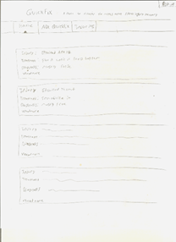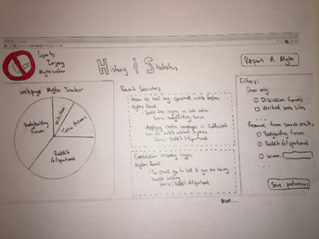

*Early sketch of a home page for the fact checker website (left) and an early sketch of the home page for the myth finder plug in (right)*

After a two user interviews on each idea, we decided to develop the Google Chrome extension. Although users liked both of the ideas, they preferred the convenience of the extension. Instead of having to go to a website and run a search for whatever online recovery method they wanted to analyze, they could simply see the information in real time directly on their page.  Although some of the details have changed, this remains the core concept of RecoverEase.

Usability Testing

As we mentioned in our “Initial Ideas” section, we decided between our fact checker website and our Chrome extension ideas by creating paper prototypes of each and conducting two user interviews for each.  Below, is an outline of the script we used to conduct these usability test for our RecoverEase Google Chrome Extension.  The full text of both of these scripts as well as the paper prototypes can be found in the appendix.

**Testing Script**

*Introduction and description of the tool

“We will ask you to complete a few tasks that involve performing a search on Google and identifying what statements are known myths, selecting which part of the body you have injured, and removing a website source from your search.”

Scenario:

        You are an amateur tennis player that just sprained your right ankle during a match. The pain is not severe enough to call for an ambulance, but you are having trouble walking it off.

Task 1

·      You suffered a sprained wrist and don’t believe that you need to go to the doctor. Search for recovery methods.

·      Click a link to find recovery methods.

·      Find the information that has been flagged by the plug-in, interact with it

·      Close the pop-up

Task 2

·      You found out that [www.WikiHow.com](http://www.wikihow.com) has been providing information that has caused further harm to recovering athletes

·      Remove [www.WikiHow.com](http://www.wikihow.com) from your search results page

Task 3

·      Find out which web source has presented you with the most sports injury related myths

·      What percentages of the myths have come from Reddit?

Task 4

·      Find your flagged search history

Critique

How intuitive do you find the design?

What did you like or dislike about the plugin/extension?

What could make the plugin more user-friendly?

Was there anything that particularly bothered you about this design?

Was there anything that you particularly liked about it?

Any other thoughts you’d like to share?

Alright, well that concludes our interview.  Thank you so much for your participation!

Before we discuss the results of these interviews, we should mention that there were some shortcomings in this script.  For example, task 1 was very directed - “first do this, then read this, then exit”.  This type of direction can be good if you are trying to get detailed information about the usability of a particular button or label, but at this point, we should have been asking broader questions to get a better idea of the user flow.  Also, some of our follow up questions, like “how intuitive do you find the design”, were vague or unclear.  What do we mean by intuitive?  How detailed of feedback do we want?  Were we to do these interviews over, we would definitely change the tasks and clarify the follow up questions.  Fortunately, despite these mistakes, our users still gave us great feedback which significantly changed our ideas.

First of all, both our users stated that there was no need to filter by sport. Nick felt that it was “pointless” and “not as important.” Matt agreed, suggesting that the initial personalized interface be redesigned to be a miniature version of larger interface containing more information - advice we acted on immediately.  Also, one user noted that he felt like there was also too much information to process on one page in the interface, leading us to create separate tabs; one for stats one for the about page, and one for history.  Finally both users also struggled with finding some buttons during the tasks.  For example, one did not immediately realize that “History and Stats” was a button, and the other did not realize that boxes had to be checked in order to save preferences. This caused us to take a serious look at our wording during the iteration, and make a number of changes.

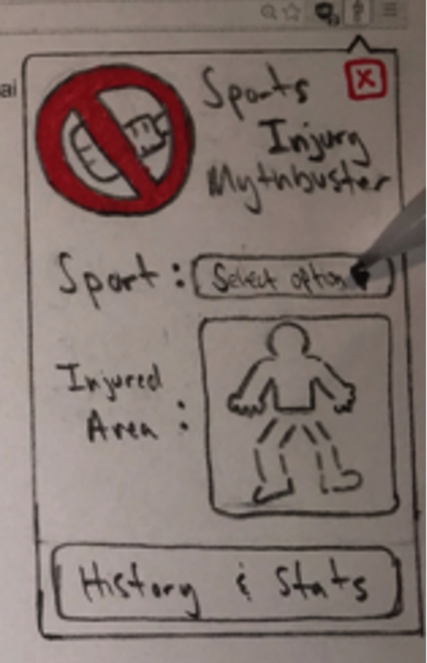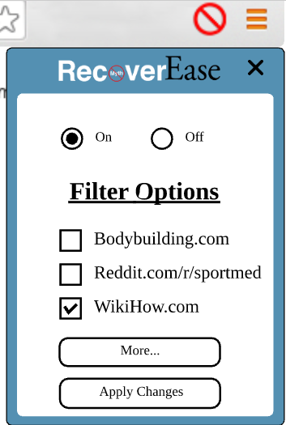

Early version of the drop-down menu with sport filtering (left) and finalized version (right).

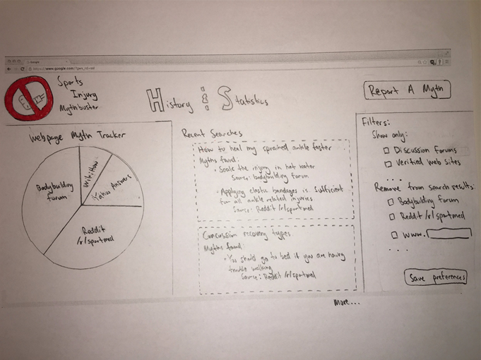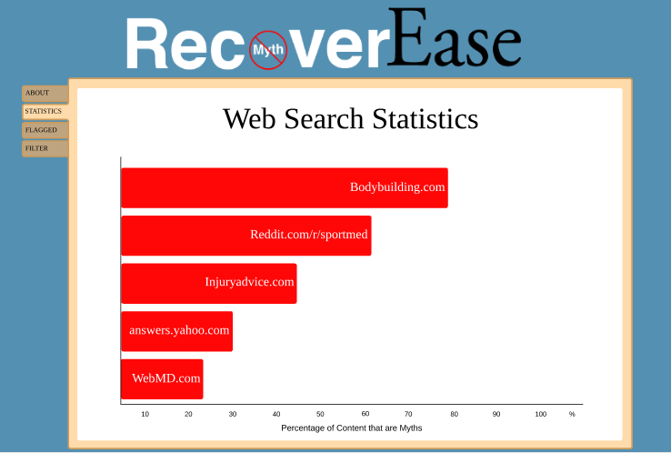

Paper prototype for the history and stats page (left) and final version of the more information page (right)

Heuristic Evaluations

In addition to usability tests, we also ran a heuristic evaluation on our second paper prototype. We found one problem in our design for each heuristic violation. After finding those issues, we made the appropriate changes to our prototype. Two examples of violations that we discovered can be found in the table below. In our second paper prototype, we initially did not have a save button or provide user feedback on the drop down menu, which violated “visibility of system status.” To fix that issue, we added a save button on the drop-down menu and pop-up to confirm that changes were made. By adding that feature, users will now know if their desired changes have been applied because they are receiving feedback. We also violated “Consistency and Standards” by naming one of our tabs “History.” That tab could be interpreted as being a traditional browser history page, so we changed the name to “Flagged.” “Flagged” is in the past-tense, which is consistent with our intent of keeping a log of past searches. By changing the name of the tab, we are eliminating any confusion the user may have with its features. Overall, we learned that our design still had small issues that would hinder usability and user experience. These issues were not found during usability testing, but running a heuristic evaluation brought these important problems to light.

|  |  |  |  |
| --- | --- | --- | --- |
| *Prior to heuristic evaluation* | *Heuristic violation* | *Description* | *After heuristic evaluation* |
| https://lh5.googleusercontent.com/PjclLFKc3VouABd6FX6WDWlzP8D1inufiEbcRc3rdM72sQ2Vmd7rYSQd1Sv6o2QE2SjKHBXVMRiOurdEjkrJF1HWZa4U0zioeai6Du3sScGNEvD4-Jo_d1NgR4PEMYbGh5_SU1yx | Visibility of System Status | Our second paper prototype did not provide user feedback when settings were saved. To fix this, we added a ‘Changes applied!’ page. This provided the user with visibility of the system’s status. | https://lh3.googleusercontent.com/_hQMlkxoqVn6Jl5y5gaDdZGMXW6FAV01OYJfIFFabJdluNdGF9Is35fcth2zYN6ibtAyEx9XKhMmDwkUUCACXks1y4cisyYyxvFlZ1B1c51XRR1u9my4PoWZokS6Vh6kXQgHMlBb |
| https://lh6.googleusercontent.com/3ZZrkBMRUSbKPbkYFt6B2WdmtmhTKNbjCXx6kH3O49rODGLt8hGZN6swY9a8lsdeqD-n-gtDyXLpyFFJM4cJrduYtsp2fduGqJsRvFddszrlx032w81wKS-r47v4R-WcxhAhRbXe | Consistency and Standards | Our second paper prototype had a ‘History’ tab. We found out that this could be interpreted as displaying the user’s internet history, rather than past flagged recovery myths. To fix this, we renamed the tab to ‘Flagged’. This would uphold standards and be consistent with web browser terminology. | https://lh4.googleusercontent.com/xKztCF8nnEOfQh6KZ4w9mt15M1fUyZrhLUddXr4x-HGhHXspsTbJC_K5R046G5x1dgFB7jy2E34igP0NazdableeFj6pqRK_k-m3b0x7uYF7REaFF9lhJaXGlWAYnD8dK83gWaG- |

Application Details

Design Description

“RecoverEase” has three components: the drop-down menu, the personalization interface, and its actual functionality. The drop-down menu is a miniature version of the much larger and more detailed personalization interface. It allows for the filtering of websites and the ability to turn the extension on and off.

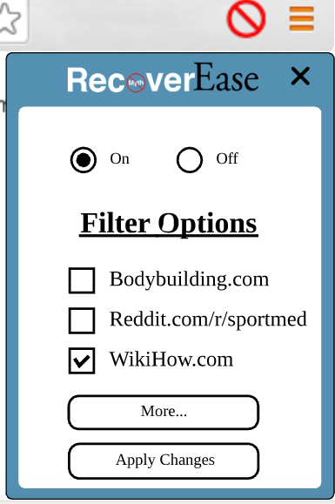

The personalization interface, which is accessed by clicking the “More…” button on the drop-down menu, contains additional content. Users are taken to “About” page that welcomes them and contains basic information about the extension when they use the extension for the first time. There are tabs for pages that can be clicked through. Those tabs are labeled “Filter,” “Statistics,” and “Flagged.” The “Filter” page is a larger version of the drop-down menu. The “Statistics” page contains data about websites that have provided questionable information, including a pie chart to help illustrate which websites have been flagged the most often. Finally, the “Flagged” page shows a log of all the times content was flagged by the extension and the websites that contained the content. Images of these screens can be viewed below and will be showcased in further detail in our “Design Decisions and Rationales” section later on.

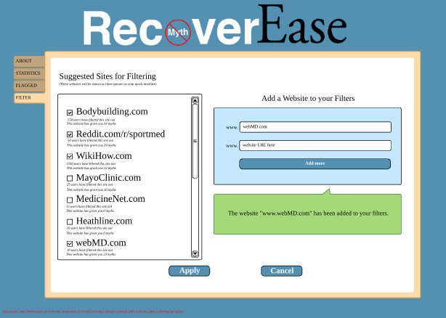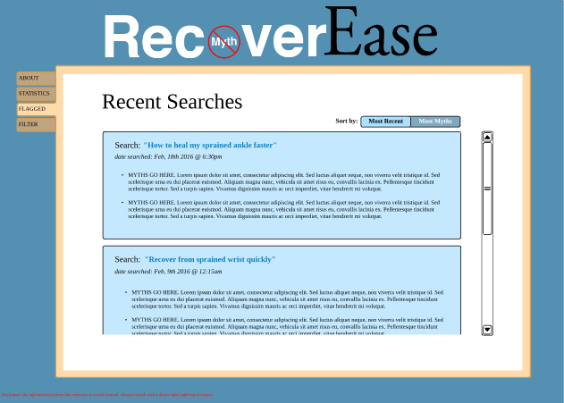

Filter page Flagged page



Statistics Page

When the extension is actually in use, all of the work is automated and the user will easily see its functionality. On a website containing questionable information, the information is highlighted in red and identified by our logo being placed next to it. When the user clicks the logo, a pop-up will appear with additional information, such as the reasoning for the content being flagged. Users can also filter out websites in the drop-down menu or the “Filter” tab, so those websites will appear as a block with an indicator that the search result has been blocked.

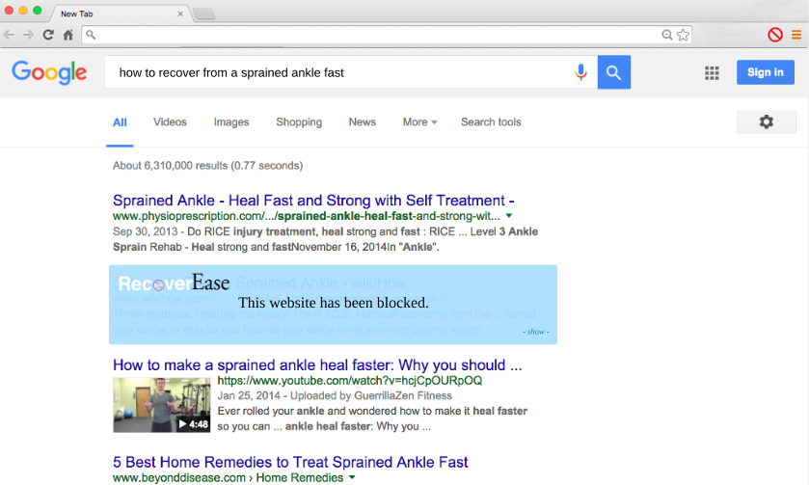

User Flow Diagram

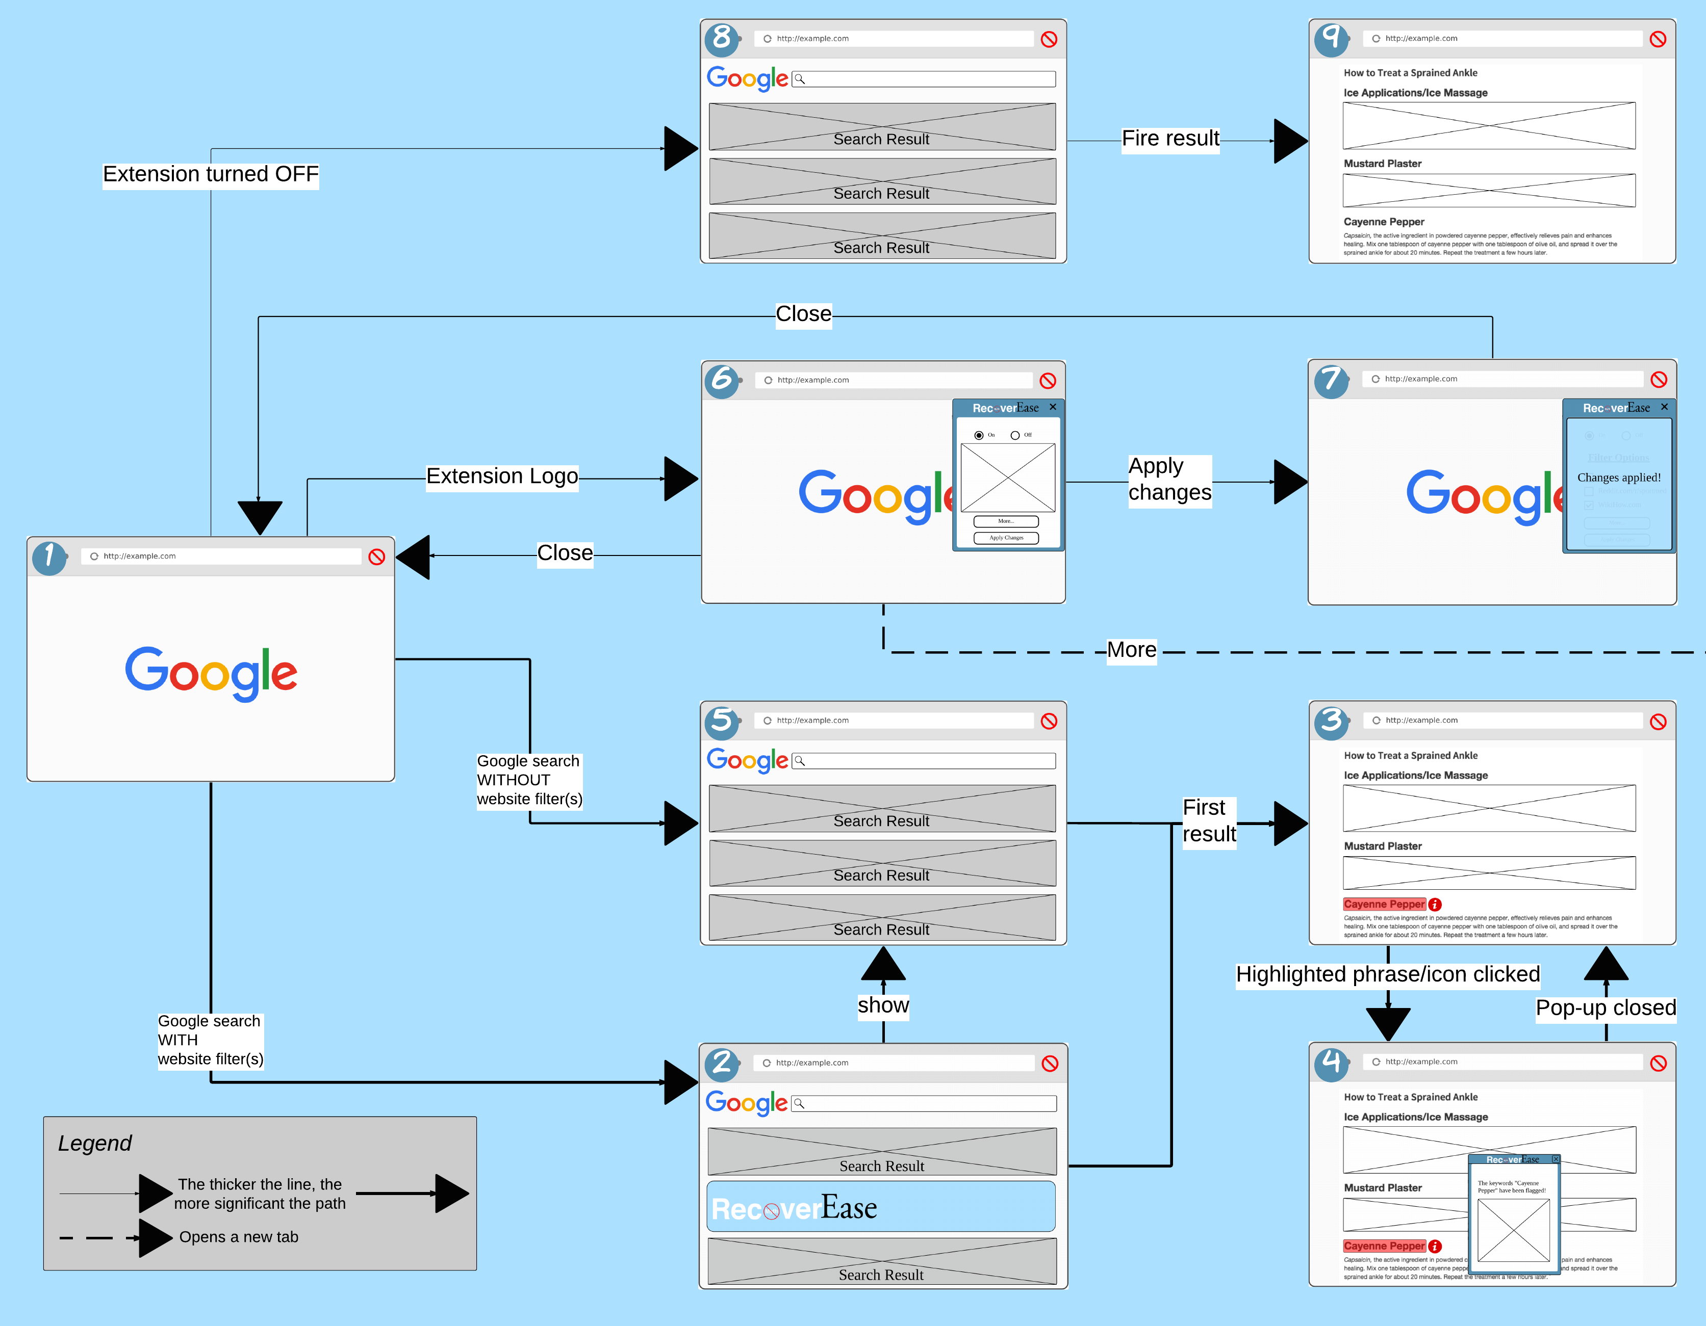

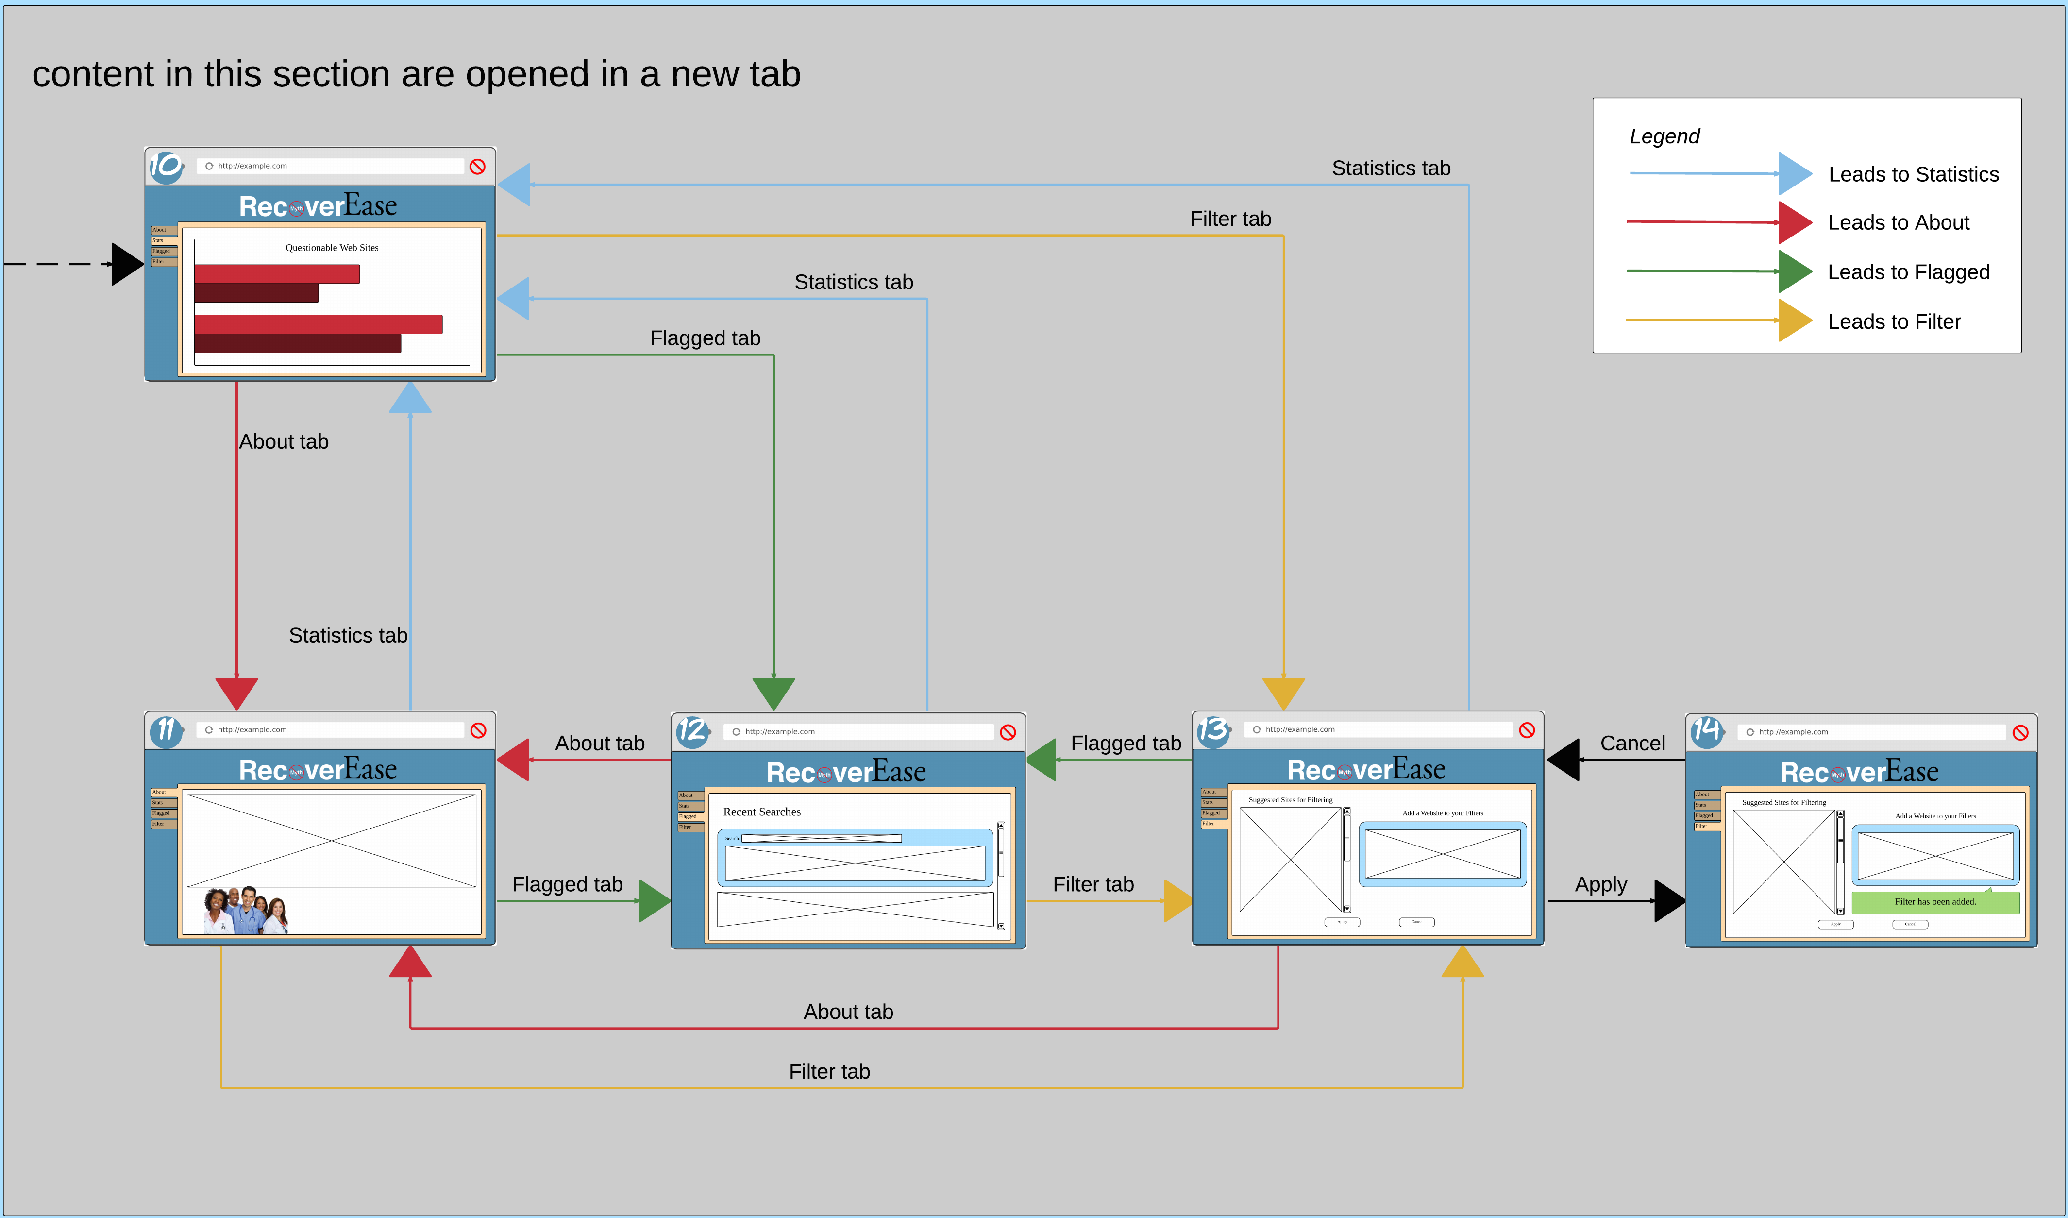

Design Decision and Rationale

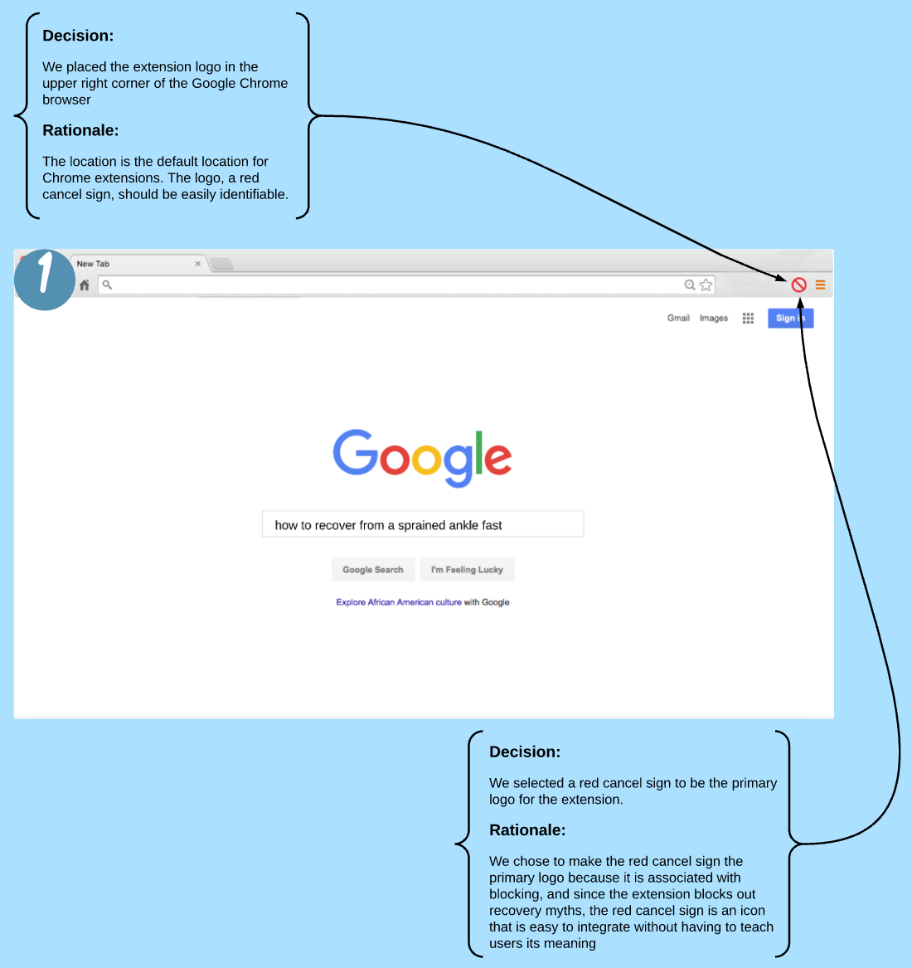

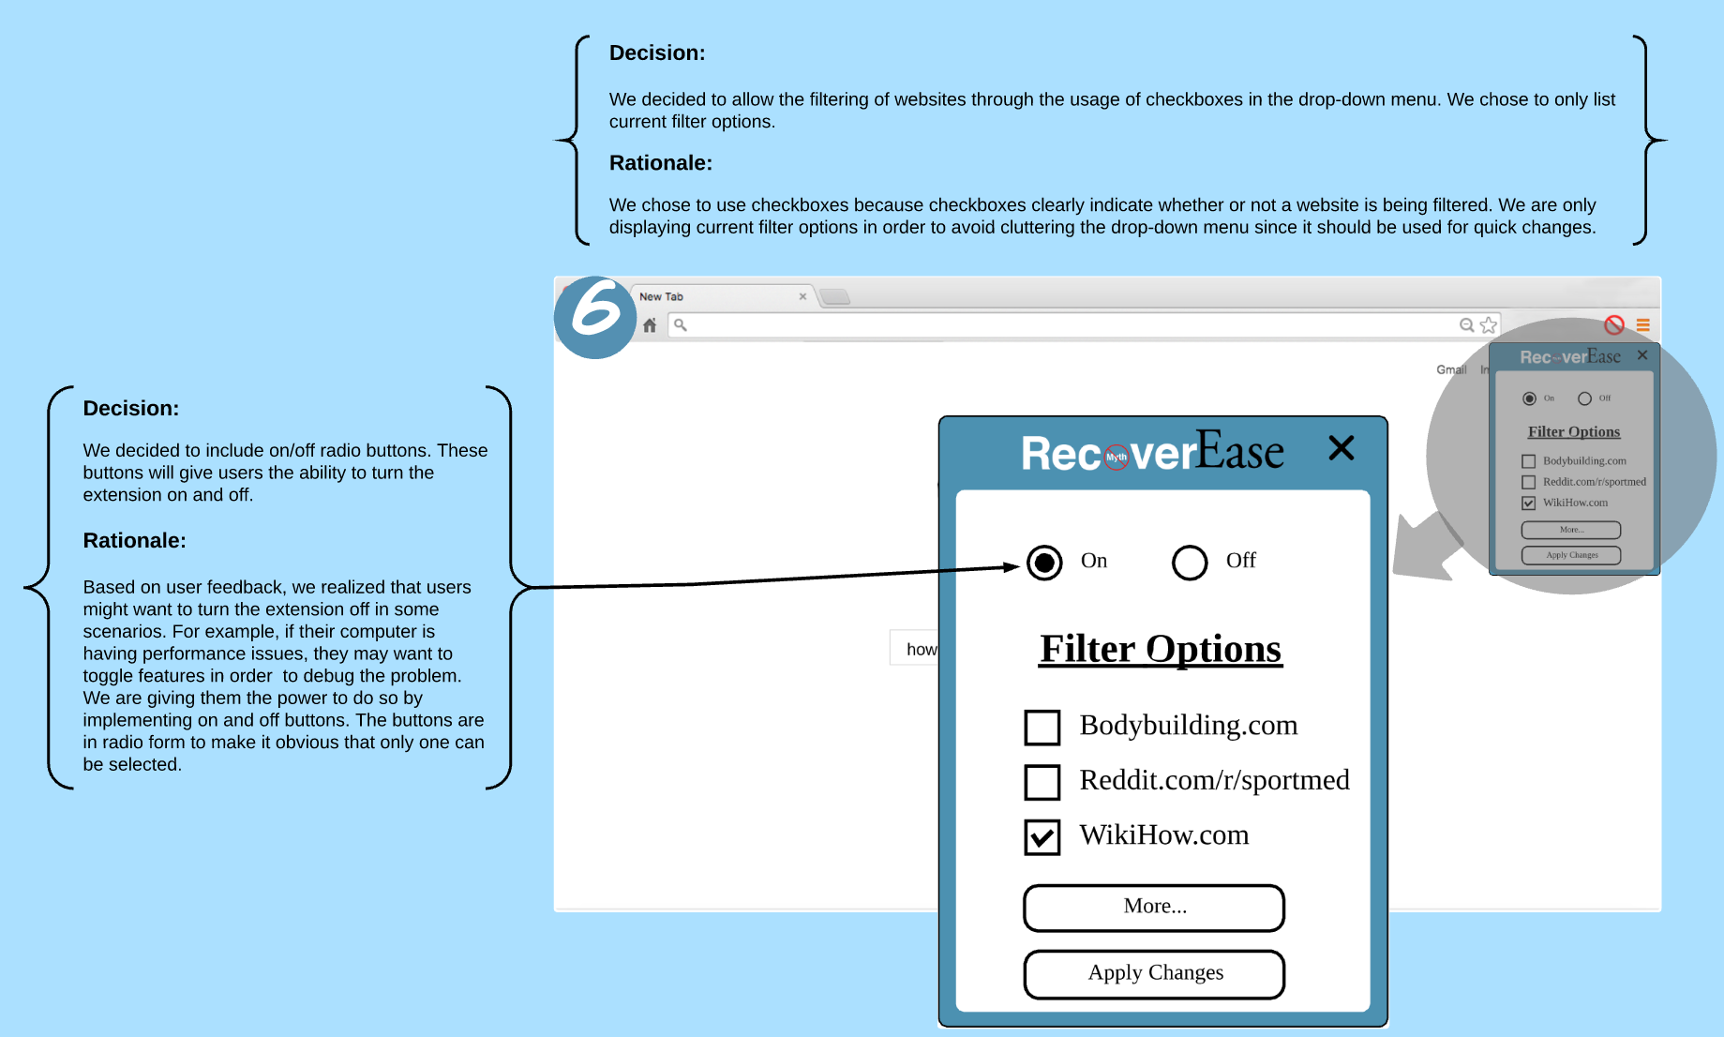

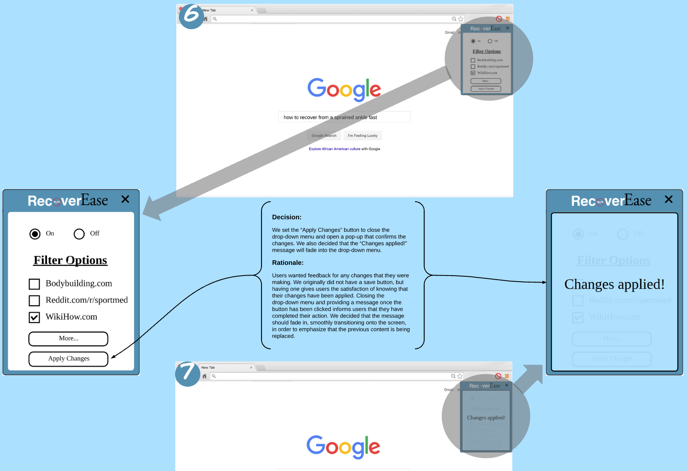

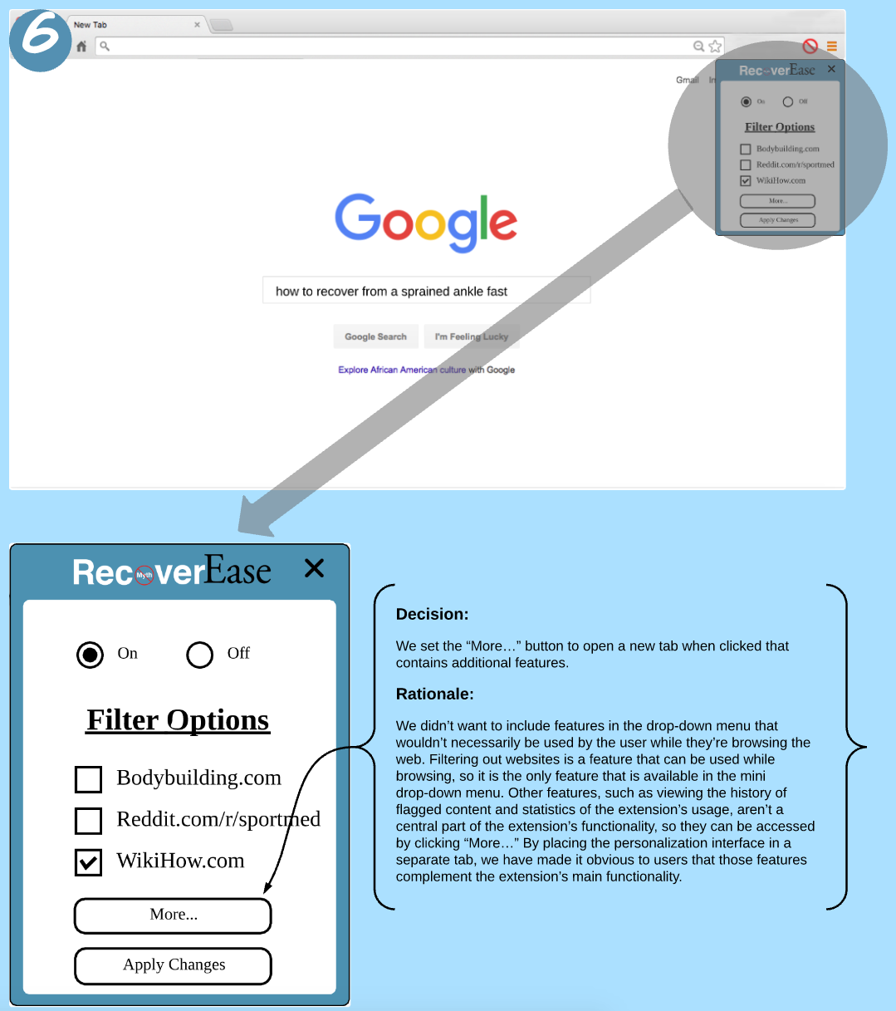

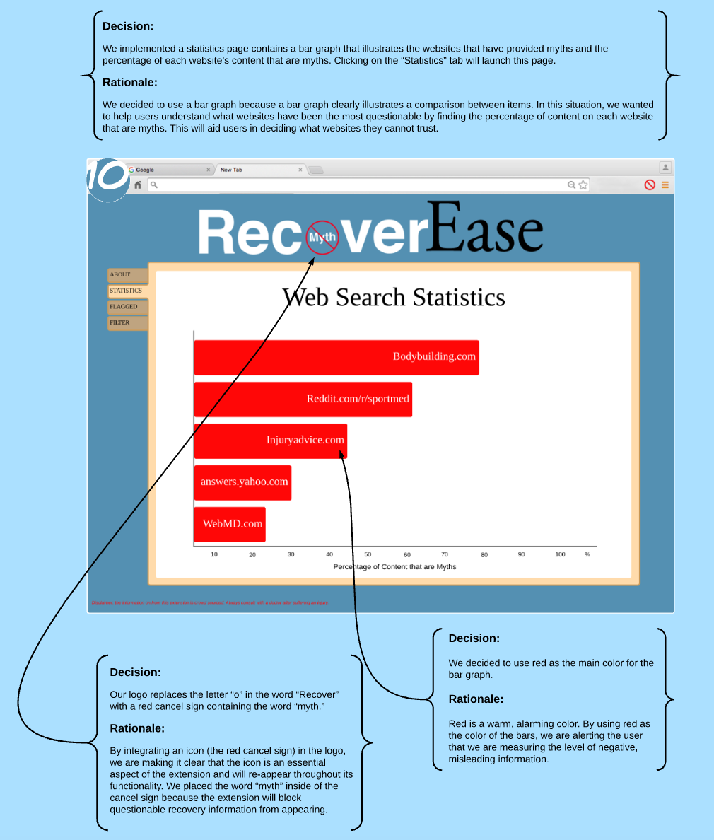

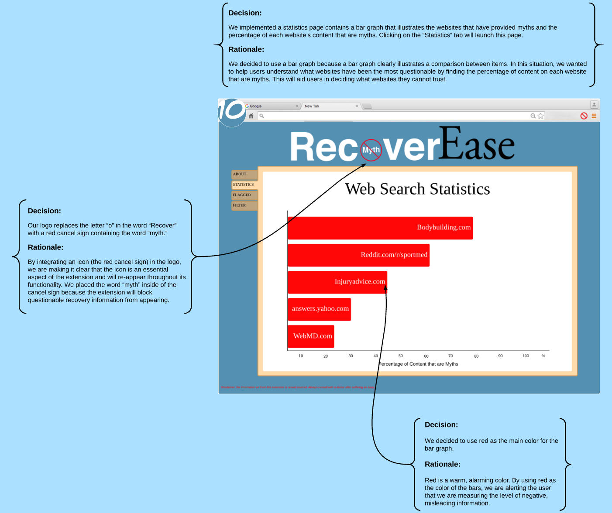

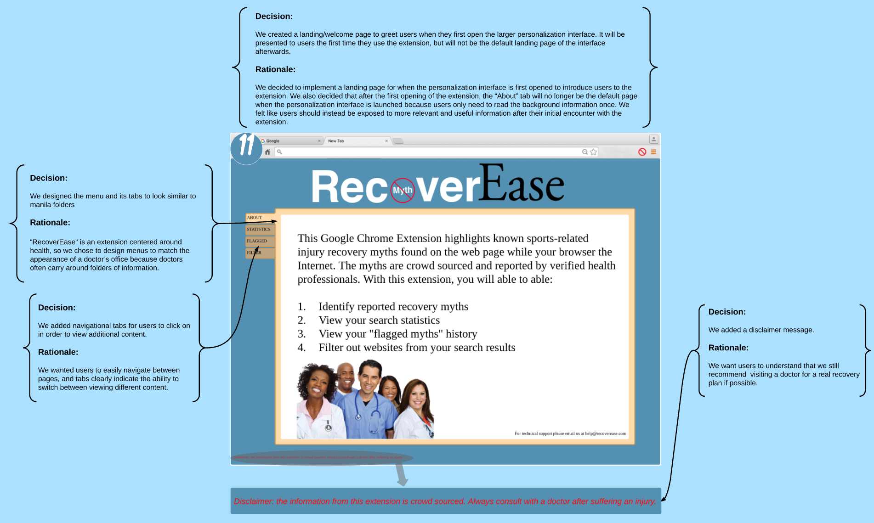

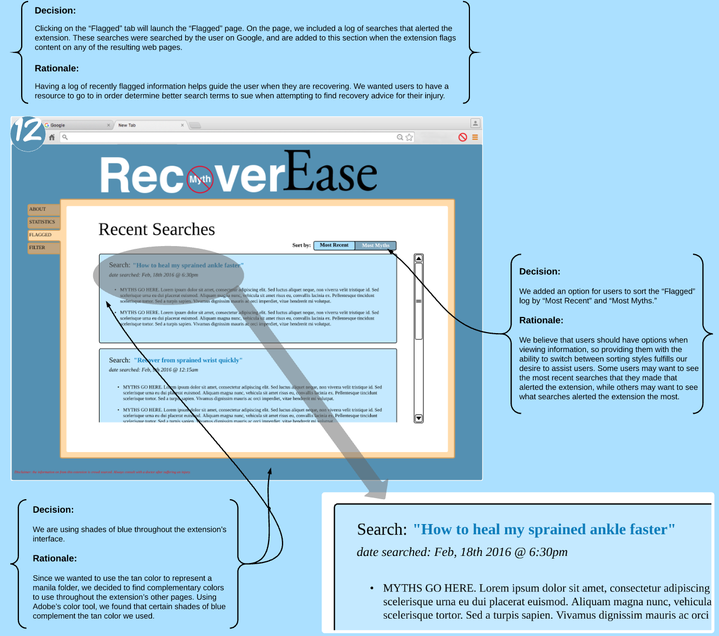

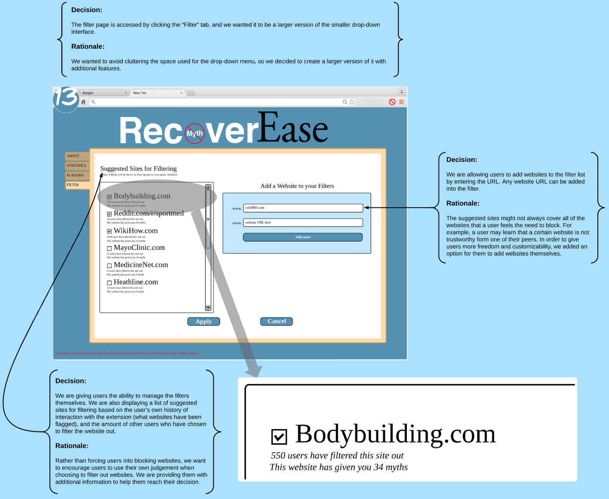

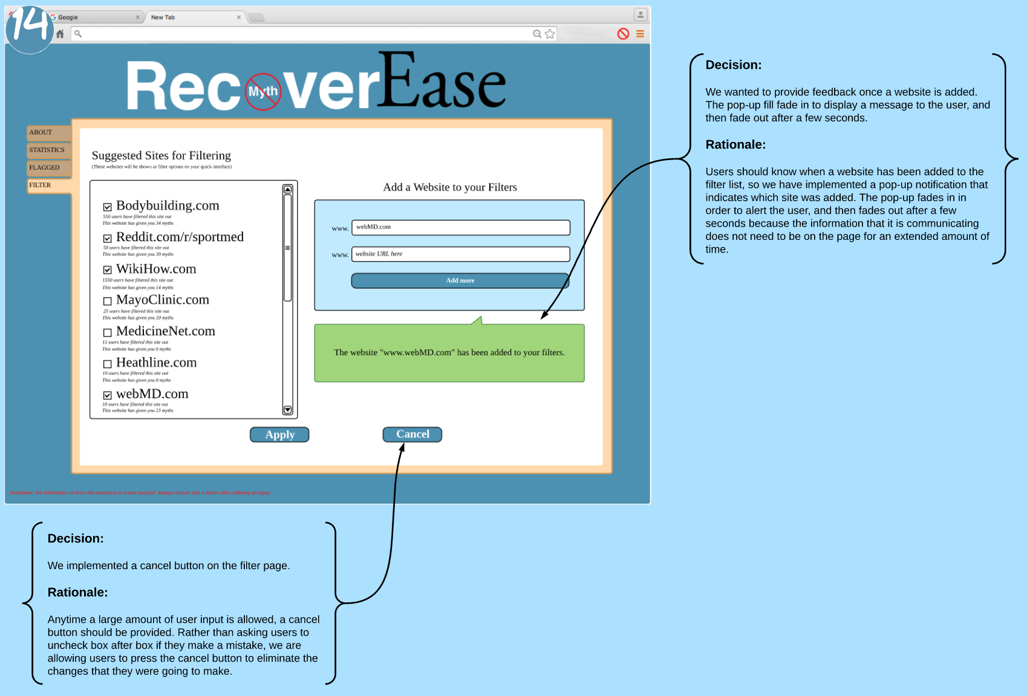

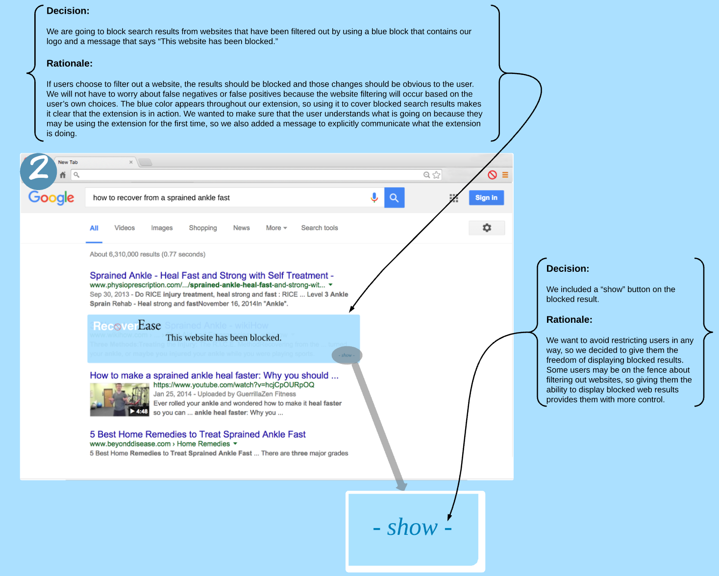

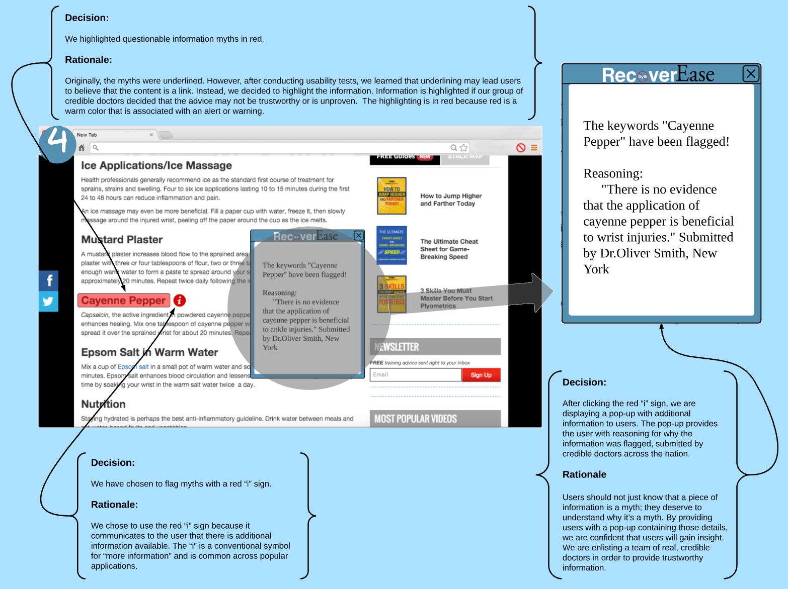

Design Limitations and Tradeoffs

Limitations

When designing “RecoverEase,” there were limitations that we had to accept. The most significant limitation is that we couldn’t design with the intent of guaranteeing a full recovery to our users. Our extension aims to make the recovery process easier and less stressful, but it cannot heal users. Similarly, we cannot be held liable for any injuries that occur while users are recovering and using “RecoverEase,” because we are not actually providing a recovery plan.

We also decided to limit the system to apply only to medium-severity, sports related injuries, such as a sprained ankle or sore elbow. These injuries are common (Jane E. Brody) in athletes, and aren’t severe enough to require surgery. Injuries that are more severe should be examined by a doctor because they are often not easily healable on their own. Medium-severity injuries may be managed by people at home and with home remedies, and our goal is to help users filter through information online to find recovery advice that is trustworthy.

In narrowing down our project scope, we also decided to design with the assumption that users will have at least a high school education. We felt like people younger than that age may not be mature or independent enough to make the decision to seek recovery methods on their own. We also felt like people with at least a high education will be better suited for understanding any complicated scientific concepts that may be displayed in the dialog box on webpages. For example, ice can help certain types of muscle pain, but aggravate others.

Another limitation of “RecoverEase” is that by using doctors as sources when flagging myths, we must obey the Health Insurance Portability and Accountability Act, or HIPPA. Doctors cannot share their patients’ information as evidence. As a result, users will have to trust what the doctors are saying without the doctors using previous patients as examples. This limitation was difficult to implement because in our interviews that we conducted in the beginning of the project, our interviewees stated that they felt more comfortable about information when other people suffered similar injuries.  However, doctors can still cite scholarly articles and research data as a replacement, meaning that credible information still exists.

Since we are relying solely on the knowledge of the doctors, there is also a limitation on what content is flagged. If a doctor doesn’t have enough evidence to fully debunk a myth, they cannot flag it with confidence. Thus, “RecoverEase” is limited by the crowd-sourced knowledge from doctors. Similarly, the amount of content that is flagged is reliant on the system working. If there is a bug that occurs, information may be incorrectly flagged or not flagged at all. We cannot promise a 100% myth-proof web search to anyone, but we are confident that our extension will help users approach information on the Internet with caution.

Tradeoffs

    Along with limitations, we also came across multiple tradeoffs when designing “RecoverEase.” We originally wanted to have users be able to self-report myths with their own explanation because after conducting our interviews, it appeared that people are more confident in information when more people agree on a topic. However, we decided that since we want to increase the reliability of user’s searches, it would not be ideal to depend on crowdsourcing information without credibility. Thus, we came to the conclusion that doctors should be the ones submitting reasoning for flags. We lose the ability for users to self-report, but gain more credibility for flag reasoning. Another tradeoff of our design is that we are trusting the user’s judgment. We didn’t want to automate any of the functionality because we feel like users need to ultimately make their own decisions based on the information we provide them. For example, when a website is blocked in the search results, users have the option to show the blocked website anyway. Users also have the ability to control the filters. We didn’t want to force users into performing any actions. We are simply giving users a guide to help ease their recovery, and they can choose how to use it.

Final Thoughts

Impact and Significance

“RecoverEase” is not a tool that will heal users with medium-severity, sports-related injuries. It is also not a tool that will provide users with a plan for recovery. Every person responds to injury treatments differently, so it would be irresponsible of us to tell users what to do to their bodies. Instead, “RecoverEase” aims to help users avoid pitfalls by identifying recovery myths.  This will make the recovery process easier and stress-free by helping users identify what not to do. Furthermore, the tool assists users in learning what websites they can trust by analyzing past myth discoveries. Suffering an injury is difficult enough, so “RecoverEase” aims to make everything else as smooth as possible.

Bibliography

Brody, Jane E. "After a Sprain, Don't Just Walk It Off." *Well After a Sprain Dont Just Walk It Off Comments*. New York times, n.d. Web. 09 Mar. 2016. <http://well.blogs.nytimes.com/2013/07/22/after-a-sprain-dont-just-walk-it-off/>

Hungerford D. Internet Access Produces Misinformed Patients: Managing the Confusion. *ORTHOPEDICS.* 1; 32: doi: 10.3928/01477447-20090728-04. <http://www.healio.com/journals/ortho/2009-9-32-9/%7Ba90511bf-8027-43ed-a0d9-d2d7c5f5e0fc%7D/internet-access-produces-misinformed-patients-managing-the-confusion>

Appendix

User Testing Script for Initial Chrome Extension Idea

* Purpose
  + The purpose of this design is to alert users when they are viewing recovery information about medium-severity sports injuries that may not be proven true. After suffering an injury, amateur athletes are likely to resort to Internet searches to find ways to recover quicker and return to their sport. The issue with that is the potential for further harm when trying recovery methods that they find on the Internet. Not everything on the Internet can be relied on, so our browser plug-in assists users with sifting through information.
* How it works
  + The plug-in works by highlighting recovery information on web pages that may be unproven or unreliable. Testing against a database, the plug-in scans the page for keywords or phrases and alerts the user when questionable information is found. The information is underlined and a flag appears next to it, and when the flag is clicked, presents the user with a pop-up containing details about the recovery method. The pop-up contains information about how many people reported the recovery method as questionable, and brief reasoning submitted by other users. The plug-in is expected to be used by injured amateur athletes who suffered a medium-severity injury (sprained ankle, sore shoulder, etc.) and want the ease and comfort of knowing that they’ll be safe from unproven recovery methods.
  + There is also an interface for users to customize their settings to fit their own preferences. This portion of the plugin will allow users to track their sports related search history. It will provide the user with statistics on which web sites have provided them with the most reliable information and ones that are plagued with myths. It will allow users to block certain websites entirely so when they search through the web the previously unreliable web page will not be visible. The plugin will allow for personalization. For example, if the user wanted to focus only on discussion forums they would be able to check a filter that will only allow for discussion boards to display on search engines. This plugin would take away the need of sifting through dozens of web pages that the user has grown to avoid. Finally, the user would be able to save their searches and findings locally to their machine, which would allow the user to access their findings
  + while not connected to the Internet. This feature is also efficient because it would prevent the user from performing redundant searches when they suffer from a similar injury.
* Task 1
  + You suffered a sprained ankle and don’t believe that you need to go to the doctor. Search for recovery methods.
  + Click a link to find recovery methods.
  + Find and click the information that has been flagged by the plug-in
  + View the details in the pop-up
  + Close the pop-up.
* Task 2
  + Open the quickview interface of the plugin
  + Change your sport to soccer
  + Select the injured area
  + Close the interface
* Task 3
  + Find out which web source has presented you with the most sports-injury related myths
  + Check what percentage of the myths came from Reddit
  + Task 4 * You found out what www.WikiHow.com has provided information that has caused further harm to other athletes’ recovery * Remove www.WikiHow.com from your search results page
* Critique
  + How intuitive did you find the design?
  + What did you like about the plug-in?
  + What did you dislike about the plug-in?
  + How would this plug-in benefit users or complement the recovery
  + Would you use this plug-in if you were an amateur athlete?
  + What could make the plug-in more user-friendly?
  + Do you have any suggestions for the improvement of this plug-in?

User Testing Script for Initial Fact Checker Website Idea

Greeting

* Hi!  Thanks for agreeing to do interview.  My name is Alex Gingras.
* So, today we’re going to be doing some very rudimentary testing of a potential web app we are thinking of developing called QuickFix.  In essence, QuickFix is designed to help people identify the various sports injury recovery myths you might find on the internet
* I’m going to show you a series of papers, which represent the hypothetical design for our website.  I’m then going to ask you to navigate through the layout to answer a few questions I’m going to ask you. You can “click” by tapping on the paper, and you can “hover” by holding your finger over the paper.
* Remember, this is testing the prototype – not you.  Anything you have difficulty with is because it was poorly designed, not because you are bad at technology.  If you have any thoughts throughout the process about difficulties you’re having, things that are confusing you, or things you particularly like, please feel free to share them!  This is a very early stage prototype, and any feedback is good feedback.

Initial questions

* Before we get started, though, I’d like to ask you a few questions about yourself.
* Do you play any sports?
* Have you ever had a sports injury?
* Have you ever tried a recovery method you found online?  Did it work?

User scenario 1

* Let’s say you recently sprained your wrist during a pick-up basketball game, and found a tip online that says light wrist stretches are a good way to heal more quickly.  How would you go about seeing if that was true or not?

User scenario 2

* Now suppose that you just jammed your thumb, and found a tip online that you can just pull on it really hard, and it’ll heal more quickly.  How would you go about seeing if that is a valid recovery method?

Questions and conclusion

* Was there anything that particularly bothered you about this design?
* Was there anything that you particularly liked about it?
* Any other thoughts you’d like to share
* Alright, well that concludes our interview.  Thank you so much for your participation!